KAMPUS.VC

Digital Risk Protection
Social & App Monitoring
Challenge Requirements, System Specification & Acceptance Plan

Purpose
Define a functional, explainable and honest prototype for identifying potential brand impersonation across social profiles and mobile-app listings, while explicitly excluding verified official assets.

1. Executive Summary
Kampus.VC’s Digital Risk Protection challenge focuses on detecting possible social-media and mobile-app impersonation of registered organizations. The prototype must use an organization’s saved brand profile as the reference for comparisons, apply an explicit verified-asset allowlist, explain every detection, and clearly distinguish live integrations from simulated demonstration data.
The two primary modules are Social Media Monitoring and App Store Monitoring. Supporting capabilities include brand onboarding, asset verification, source health, configurable detection and risk scoring, case investigation, dashboard metrics, and submission deliverables.

2. Challenge Objectives
- Register and maintain a brand profile containing identifiers, official accounts, apps, images, domains and keywords.
- Identify potentially impersonating social profiles and company pages using multiple explainable indicators.
- Identify suspicious Android and iOS app listings by comparing branding, developer identity and metadata.
- Exclude verified official profiles and applications from active impersonation alerts.
- Control false positives through review, dismissal, analyst confirmation and recorded reasons.
- Show source availability and label synthetic data honestly when live authorized integrations are unavailable.
- Deliver a reproducible prototype, architecture diagram, demo script, presentation and setup documentation.

3. Brand Onboarding and Official Asset Management
Provide a brand setup workflow with fields for:
- Brand/company name and alternative names.
- Official logo and additional brand images.
- Official social media accounts and company pages.
- Official mobile application names and official app-store listing URLs.
- Official developer/publisher names and app identifiers, including package names or bundle IDs where available.
- Approved domains and relevant brand keywords.

3.1 Verified-Asset Allowlist
- Store official social accounts, pages, apps, listing URLs and identifiers as verified assets.
- Exclude a candidate from active impersonation alerts when it matches a verified official asset.
- Allow authorized users to review, verify, edit and remove official assets.
- Record verification status and relevant metadata so exclusion decisions can be audited.
- Display excluded matches as Official Asset where useful, without counting them as active threats.

4. Social Media Monitoring — Primary Module
The module should identify potential fake profiles, fake company pages, unauthorized brand pages and scam accounts.

4.1 Detection indicators
- Profile display name and username similarity to the registered brand and its alternative names.
- Character swaps, misspellings, inserted or removed words, spacing, punctuation and capitalization changes.
- Commonly substituted characters and look-alike character patterns.
- Logo/profile-image similarity when image analysis is available.
- Description and brand-keyword similarity, plus other available account metadata.
- Official-asset allowlist match and other exclusion rules.

4.2 Finding details
- Profile name, platform, profile URL and suspected brand.
- Matching indicators and a clear explanation of why the result was flagged.
- Risk score, confidence, evidence, detection time and investigation status.
- Data-source label and last-synchronized timestamp.
- Investigation actions and a way to record analyst notes or false-positive reasons.
Do not flag an account solely because it shares a common word or has a similar name. Combine multiple indicators where possible, disclose unavailable signals, and treat the score as a prioritization aid rather than proof of malicious intent.

5. App Store Monitoring — Primary Module
Provide a dedicated view for suspicious Android and iOS application listings.

5.1 Comparison indicators
- App name similarity to registered official apps.
- App icon/logo similarity when image analysis is supported.
- Developer or publisher identity.
- Description and branding similarity.
- Package name or bundle identifier where available.
- Official store listing URLs and other available metadata.

5.2 Candidate app details
- Candidate app name, store/platform, developer and listing URL.
- Official-app comparison and matching indicators.
- Evidence, risk score, confidence and investigation status.
- Data-source label and last-synchronized timestamp.
A similar name or icon published by a different developer should receive additional scrutiny, not automatic classification as malicious. Verified official listings and identifiers must be excluded from suspicious-app alerts.

6. Explainable Detection and False-Positive Control
Use a configurable detection engine combining the following signals:
- Normalized name matching.
- Fuzzy string similarity.
- Character-confusion and look-alike matching.
- Logo or image similarity where supported.
- Publisher/developer comparison.
- Description similarity.
- Verified official-asset exclusion rules.

6.1 Required result categories
- Potential Threat
- Needs Review
- Confirmed by Analyst
- Dismissed
- Official Asset
Every result should show the individual indicators that contributed to the decision. Analysts must be able to mark false positives and record a reason. Risk scores are prioritization signals, not proof of malicious intent.

7. Source Availability and Data Integrity
Create a connector layer for authorized social monitoring sources and app-store metadata providers.
- Show each source as Connected, Unavailable, Demo Mode or Experiencing Errors.
- When live data is unavailable, use clearly labelled synthetic records to demonstrate the end-to-end workflow.
- Never describe synthetic records as live detections or claim a platform is monitored without a working authorized integration.
- Display source labels and last-synchronized timestamps on relevant findings.
- Provide useful loading, empty and source-unavailable states.

8. Suggested Architecture
Recommended logical components: web interface; brand and asset management; connector adapters; normalization; official-asset allowlist; detection engine; risk scoring and evidence generation; database; investigation workflow; dashboard and reporting.
Authorized social sources App-store metadata sources
\ /
+---------- Connector layer ----------+
|
Normalize metadata
|
Brand profile + verified assets --> Official-asset exclusion
|
Detection engine
|
Indicators + risk prioritization
|
Findings database
|
Dashboard / Alerts / Case investigation / Reports
The exclusion check should be an explicit, testable stage. It should prevent verified official assets from becoming active impersonation alerts, rather than relying only on a low risk score.

9. Data Model — Minimum Records

Brand profile
- Brand ID; primary and alternative names; keywords; approved domains; logo/image references; created/updated timestamps.

Official asset
- Asset ID; brand ID; asset type; platform/store; canonical URL; account/app identifier; developer/publisher; verification status; verification metadata.

Finding
- Finding ID; candidate type; candidate name and URL; platform/store; suspected brand; official comparison.
- Matching indicators and evidence; risk score; confidence; detection time; source label; last synchronization time.
- Status; analyst notes; false-positive reason; created/updated timestamps.

Source connector
- Connector ID; provider/source name; connection state; last successful synchronization; last error; demo/live mode.

10. Dashboard and Investigation Requirements
- Dashboard totals must be derived from stored findings and agree with the findings list.
- Separate counts for Potential Threat, Needs Review, Confirmed by Analyst, Dismissed and Official Asset.
- Allow analysts to open a finding, inspect evidence, record notes, update status and generate an investigation summary.
- Provide useful loading, empty and source-unavailable states.
- Show source provenance and synchronization time to avoid confusing simulated records with live data. 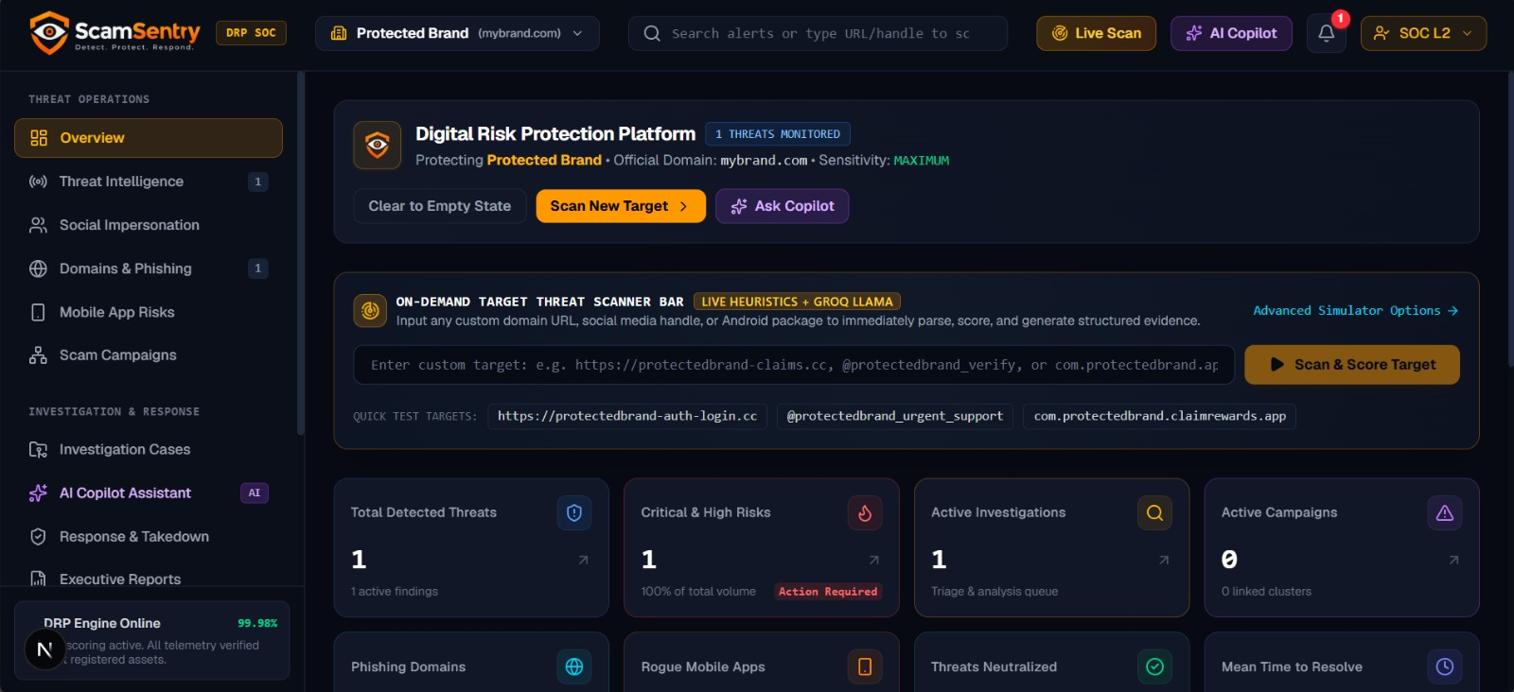

11. Required Submission Deliverables

11.1 Architecture diagram
Show data sources, brand asset storage, normalization, official-asset exclusion, detection logic, risk scoring, database storage and user interface. 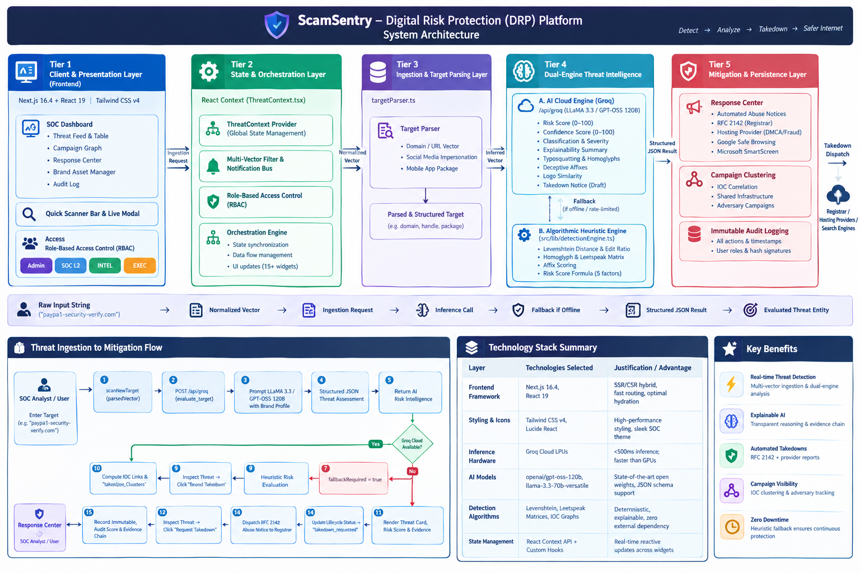

11.2 Short demo script
- Register a sample brand and add official social accounts, app listings and identifiers.
- Verify the official assets and show the allowlist.
- Run a reproducible dataset containing a suspicious social profile and a fake company page.
- Show look-alike matches involving spacing, inserted words, misspellings or character substitutions.
- Show a suspicious app with similar branding and a different developer, explaining why this merits review.
- Demonstrate that registered official profiles and applications are excluded from active alerts.
- Open a finding, review its evidence, update its status and generate an investigation summary.
- Show source labels, source-unavailable/demo states and dashboard metrics.
- Demo: https://drive.google.com/file/d/10hfdFhOSfNIopEYmzbiHbc-mMR0o3D2g/view?usp=drivesdk

11.3 Five-slide presentation
- Problem — brand impersonation on social media and app stores.
- Solution — brand onboarding, official-asset exclusion and explainable detection.
- Architecture — connectors, normalization, exclusion, detection, database and interface.
- Demonstration — suspicious profile, suspicious app, official exclusion and case investigation.
- Limitations and next steps — source access, simulated data, image-analysis coverage and integration roadmap. 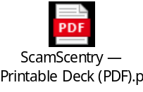

11.4 Setup and source documentation
- Installation and configuration steps, required environment variables and run commands.
- Supported data sources and the status of each connector.
- A clear feature matrix separating live, simulated and unavailable capabilities.
- Instructions for loading the reproducible acceptance-test dataset.

12. Final Acceptance Test
- ☐ Register a brand and its official social accounts and mobile applications.
- ☐ Detect a fake social profile with a similar name or logo.
- ☐ Detect a fake company page or suspicious brand account.
- ☐ Detect a suspicious app with similar name or logo but a different developer.
- ☐ Identify look-alike names involving spacing, inserted words and character substitutions.
- ☐ Exclude registered official profiles and applications from active impersonation alerts.
- ☐ Explain every detection with visible evidence and matching indicators.
- ☐ Show useful empty, loading and source-unavailable states.
- ☐ Generate a clear investigation summary and update case status.
- ☐ Verify that dashboard metrics match the stored findings.

13. Limitations and Responsible Interpretation
Similarity does not establish intent. Legitimate fan pages, resellers, regional accounts, app rebrands or authorized partners may resemble a registered brand. Findings should be treated as leads for review, not as automatic accusations. Detection quality depends on metadata access, source coverage, image-analysis availability and the completeness of the brand’s verified-asset inventory.
The prototype should not claim comprehensive platform coverage where APIs, permissions or provider access are unavailable. Any simulated source, image-comparison limitation or missing metadata should be disclosed in the UI and setup documentation.

